# Introduction

There is one video of a fixed traffic camera facing a street junction. Some physical measurements are also provided in the sample image. The problem is to **locate the vehicles (mostly cars) in the bird-eye-view (BEV) image**.

The measurements are captured from Google Earth Pro software. Therefore, there might be some inaccuracies on these measurements.

Please do not spend more than 4 days and provide your deliverables to us.

## The input video

[video_01.mp4](https://drive.google.com/file/d/1R9Y26vz9wX5NB7FxYD3oojHOkhtQ9YUc/view?usp=sharing)

## Physical measurements

The camera view: [camera-view.png](https://drive.google.com/file/d/1-d8lxW_bIkEuH53GbSaASD4NVQZuuwW-/view?usp=sharing)

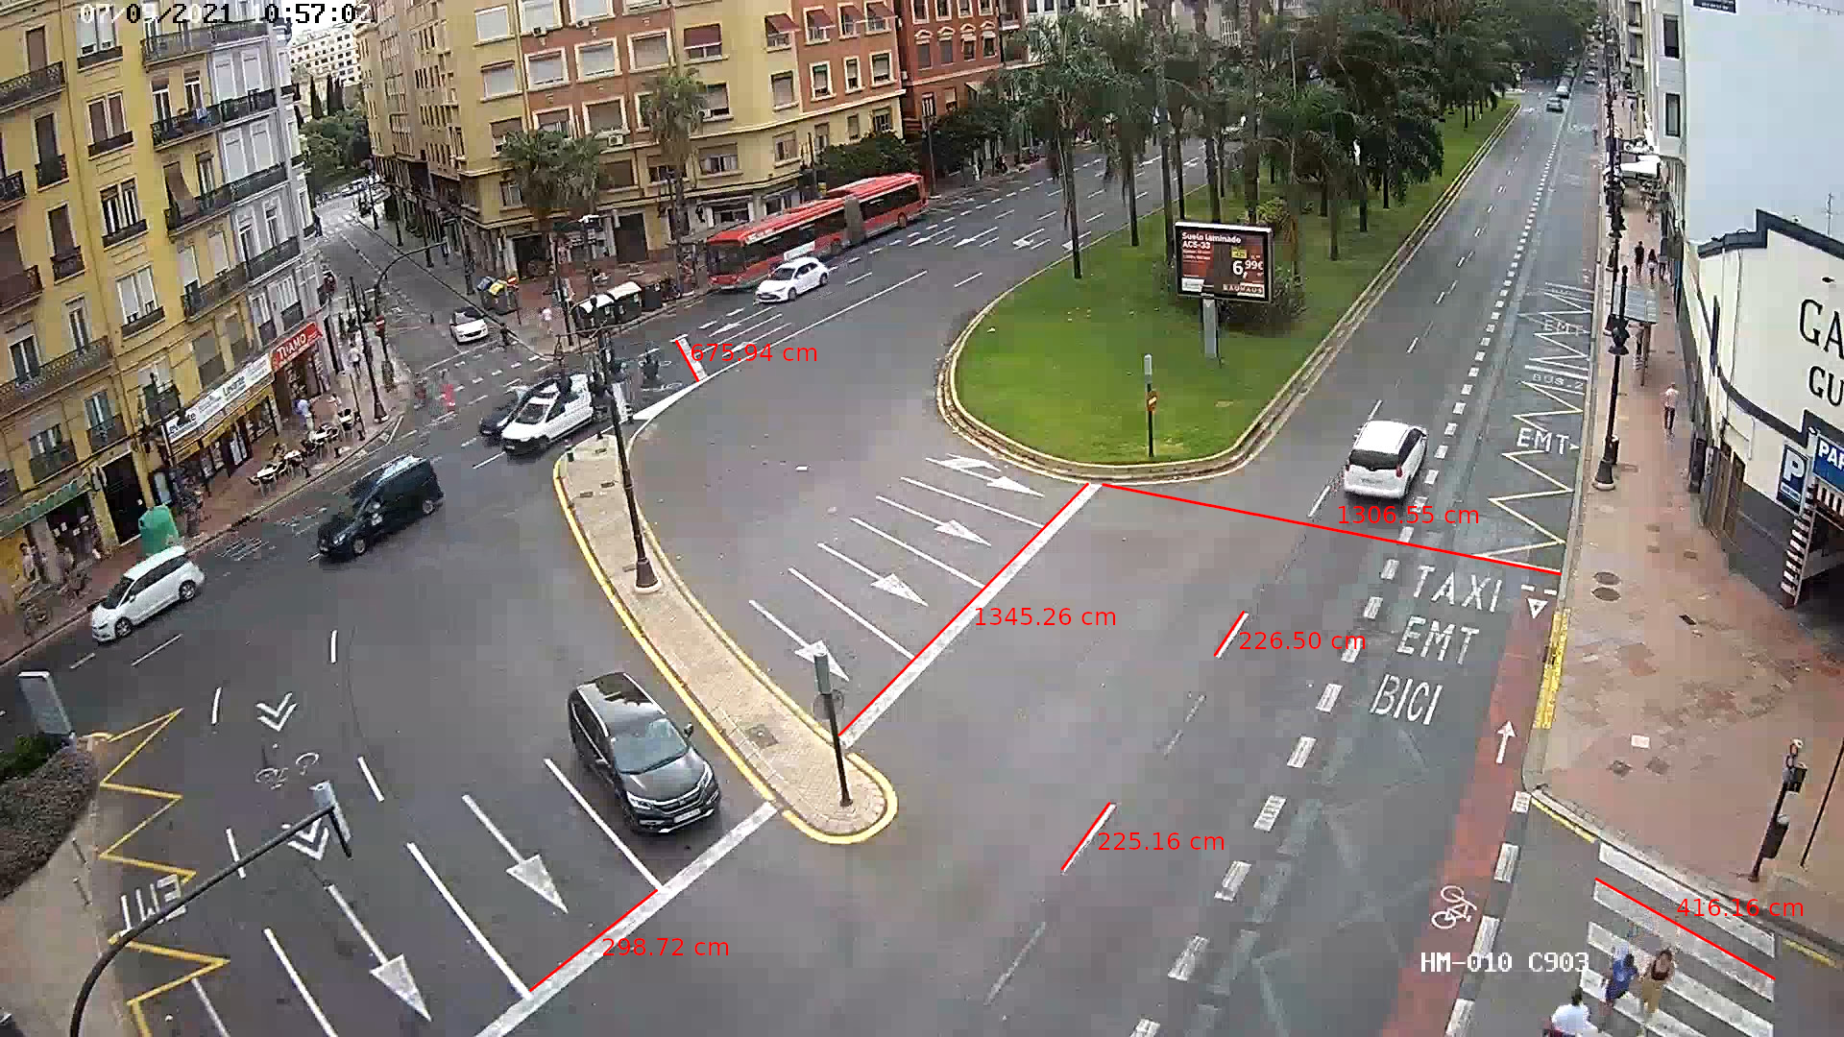

The desired BEV: [google-earth.png](https://drive.google.com/file/d/1gZdO-9UXGQnBJwfpLJvwmzakHNGF85Bz/view?usp=sharing)

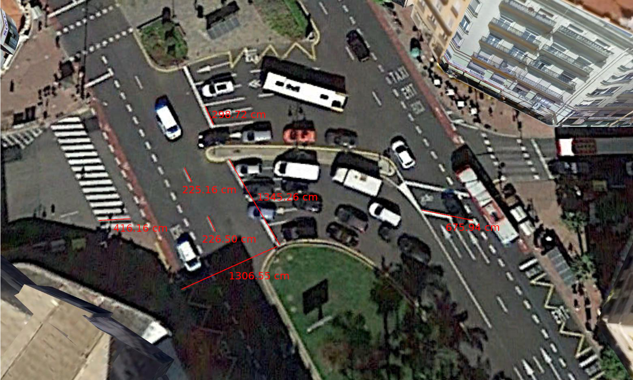

## Notes

* You may use different color/size 2D boxes for different vehicle types.
* You may use a 2D plane to overlay the location of the vehicles or alternatively the following image. Note that this is an *old* street view of this junction and does not completely align with the current situation. (For example the cross lines are not available now) [Google_earth_old.png](https://drive.google.com/file/d/1dUJEVpsjBCDrOjsm_BsNoWukVsy3z305/view?usp=sharing)

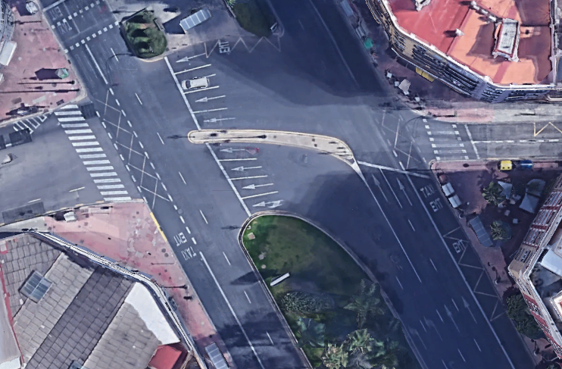

* The kml files of the above measurement are also provided if you want to get better images and measurements for any other locations in the scene. [measurements.kml](https://drive.google.com/file/d/1ZYgcOpCRI2zAdtoxP4q77N5FXpV765WO/view?usp=sharing)
* If you need more measurements and extra parameters, you may assume/estimate some values and discuss them in your report.

## Primary Deliverable

1. The general model proposal/algorithm for solving the problem, which can include object detection, tracking, 2D to 3D transformation, etc. Your model can be separated pieces of codes or the combination of all. It really depends on how you think about the problem. You may provide pros and cons of different strategies to tackle this issue.
2. You may choose any platform to generate your report including github, jupyter notebook, pdf, html, ...

## Secondary Deliverable

1. A runable code written in your preferred programming language. You can have your assumptions on any input data that you think is missing.
2. Ideas or suggestions on how to improve the whole model or different parts of it.

If you have any questions please do not hesitate to contact Shahab: [shahab.e@unleashlive.com](mailto:shahab.e@unleashlive.com)